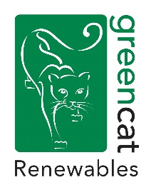
Senior/Principal Environmental Consultant
Location: Edinburgh

GCR Technical and Environmental Services are looking for an experienced environmental consultant to join the team. The candidate will manage the delivery of services for a range of renewable energy projects, primarily medium to large scale onshore wind farms, and to help develop new and strengthen existing client relationships.

The Role
- Project Management of renewable energy projects of all scales from initial feasibility through to planning determination.
- EIA co-ordination and Management.
- Production & review of EIA Reports
- Management of EIA project team and subcontractors.
- Working closely with other GCR departments to provide a holistic approach to site design and development.
- Project management.
- Client relationship management.
- Business development including preparation of tenders/proposals, following up leads, and identifying new business opportunities.
- Mentoring and support of junior staff.

The Candidate
- Degree qualified in a relevant Planning, Environmental or Engineering discipline.
- At least three years in environmental consultancy, or related role.
- In-depth understanding and awareness of the key environmental and technical issues involved in the development of renewable energy projects.
- Strong knowledge of the EIA Process and the UK planning system, in particular, the Scottish planning system.
- EIA Management experience – LPA and ECU Applications.
- Public Inquiry Experience, wind farm and transmission scale project work would be desirable.
- Technically competent with strong problem solving, communication and computer literacy.
- Proficient and persuasive report writing skills, maintaining a high quality of work whilst adhering to deadlines.
- IEMA, or other relevant association, membership preferred.
- Valid Driving Licence for use within UK is essential.
- Motivated and proactive, with an adaptable mind-set and a willingness to work independently or as part of a team.
- Excellent attention to detail and organisational skills.

To apply please send a full CV and covering letter to jobs@greencatrenewables.co.uk by the 19th of November 2021.

