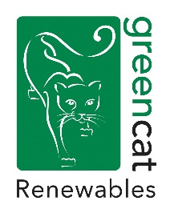
Planning/Environmental Graduate
Location: Edinburgh

GCR Technical and Environmental Services requires a Planning/Environmental Graduate to join the team. The candidate will be part of the delivery of services for a range of renewable energy projects, primarily medium to large scale onshore wind farms.

The Role
- Undertaking feasibility studies, show-stopper reviews and project viability assessments.
- Constraints mapping, initial site design and energy yield assessments, using a range of software packages such as GIS, WindFarm, Openwind and PVSyst.
- Preparation of formal consultation documents for local authorities and statutory consultees.
- Undertaking pre-application engagement with local authorities including screening and scoping exercises.
- Assistance in the production and co-ordination of EIA and planning application documentation, including drafting of technical and non-technical elements, landscape photography and figures.
- Providing support to members of the Technical and Environmental Services team as necessary.

The Candidate
Essential
- Degree qualified in a relevant Planning, Environmental or Engineering discipline.
- Technically competent with strong problem solving, communication and technical report writing skills.
- Good computer literacy, high level of proficiency in MSOffice programmes.
- Willingness to undertake travel and occasional overnight stays.
- Valid Driving Licence for use within UK.
- Proactive, adaptable mind-set with a willingness to work independently or as part of a team.

Desirable
- Knowledge of the UK planning system.
- An understanding and awareness of the key environmental and technical issues involved in the development of renewable energy projects, particularly onshore wind and solar.
- Ability to use WindFarm, GIS software, AutoCAD, Adobe Illustrator and Photoshop would be beneficial.
- Excellent attention to detail and organisational skills.

Benefits
- Pension
- 33 days annual leave.
- Professional development opportunities.
- Option to join the Cycle to Work Scheme.

To apply please send a full CV and covering letter to jobs@greencatrenewables.co.uk by the 19th November 2021.

