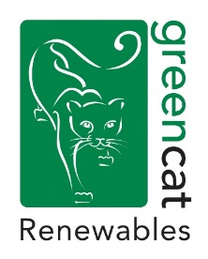
Green Cat Renewables Job Advertisement –
Renewables Asset Manager (Biggar/Edinburgh)

Location option: Bethany Hall, 29a High Street, Biggar/ Stobo House, Roslin, EH25 9RE

The Company
Green Cat Renewables Limited (GCR) is a dynamic, innovative company that provides the complete range of consultancy support services for the onshore renewable energy industry - primarily wind, solar and hydro. The company was founded in 2005 and now comprises a multidisciplinary team of over 50 specialist consultants across three offices in Edinburgh, Livingston and Biggar.
Due to ongoing growth within the business, we are now looking to add an experienced Asset Manager to our team of asset management coordinators - the opportunity to lead this team exists for the right candidate. You will be responsible for the day to day managing of a range of renewable energy assets, ensuring that the performance of the assets is in line with expectations. You will be responsible for optimising the performance and returns whilst ensuring that improvements are identified for a diverse range of customers.

In your role, you will over oversee a variety of operational, commercial, and financial matters with the running of the operational projects.

The Role:

- Ensure contractual compliance with all commercial agreements
- Coordinate with the Asset Management team to ensure optimal performance of our portfolio of assets
- Responsible for managing the internal and external forecasts and budgets
- Implement processes and procedures for managing and reporting the performance of the assets
- Prepare financial and operational variance reports
- Liaise with internal and external teams with regards to repairs and maintenance of the assets

The Candidate should:
- Have excellent organisational and problem-solving skills
- Be a team player
- Have good people and communication skills, being equally at home facing clients, coordinating 3rd party suppliers or liaising with internal staff
Have experience in onshore wind, solar and/or hydro asset management

To apply please send CV and covering letter to jobs@greencatrenewables.co.uk by 01st of February 2022.

