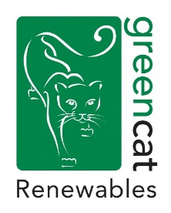
Green Cat Renewables Job Advertisement – CAD Engineer/Technician

Location: Edinburgh (Stobo House, Midlothian Innovation Centre, Roslin)

The Company
Green Cat Renewables (GCR) is a dynamic, innovative company that provides the complete range of technical services required to deliver renewable energy projects. The team of over 50 Engineers and Environmental Consultants deliver projects on behalf of Clients from three offices in Edinburgh, Livingston and Biggar.
Through the Engineering Department the company provides Client’s Engineer and Project Management services to clients developing renewable energy projects. This includes: civil, structural and electrical design; procurement; project finance technical assistance; contract preparation, negotiation and management; site supervision; civil and electrical commissioning inspections; whole project management.
Green Cat Renewables require a CAD Engineer/Technician to join the Engineering team in Edinburgh to work closely with the team providing technical drawings of detailed designs to be used in the construction of wind farms, hydropower schemes and solar farms, as well as other civil and/or structural works, both in the UK and overseas.

The Role

- Work with Engineering team to provide technical drawings and models for renewable energy projects
- Provide support to the Technical and Environmental Services team through preparation of drawings required for planning submission and other elements as required.
- Opportunity to gain experience with Revit, CADSRC, MicroDrainage and Civil 3D software
- Continuing Professional Development with regards to the CAD software, BIM (Building Information Modelling), design and relevant standards – work towards EngTech status with ICE.
- Quality management of drawing issue and circulation.

The Candidate

- Minimum 2 years’ experience with CAD software in an engineering environment
- Willingness to learn and maintain CPD.
- Willingness to travel within UK when required (infrequent).
- Valid Driving License for use within UK.

To apply please send a full CV and covering letter to jobs@greencatrenewables.co.uk by the 18th March 2022.

